Jackdaw
- Bilge Rat
- Member

- 10 posts
Posted July 29, 2010 · Report post
I did a bit of searching on this forum and got the impression right or wrong that cigarettes were not around in the GAOP
but wikipedia says
The South and Central American cigarette used various plant wrappers; when it was brought back to Spain, maize wrappers were introduced, and by the seventeenth century, fine paper. The resulting product was called papelate and is documented in Goya's paintings La Cometa, La Merienda en el Manzanares, and El juego de la pelota a pala (18th century)
And I found this is from Brittania Concise Encyclopedia
Early in the 16th century beggars in Sevilla, Spain, began picking up discarded cigar butts and wrapping them in scraps of paper to smoke, creating the first European cigarettes
and then I found this timeline, which if you are interested in the dreaded weed is fascinating , it catalogues in some detail the rise and fall of tobacco,
check out 1614 in Spain. Pirates must have been smoking early cigarettes all through the GAOP surely, and probably all over the place
http://www.tobacco.org/resources/history/Tobacco_History17.html
I think it looks pretty conclusive on the face of it, I haven't been able to follow up any of the references but interested to hear your comments. Looks like y'can started rolling yer own, Jim Lad
Jackdaw

michaelsbagley
- Smells Like Wet Sheep
- Moderator

- 2,548 posts
- Gender:Male
- Location:Columbus, Ohio
- Interests:Mostly into GAoP, but starting to develop more Buccaneer era stuff for re-enacting as well. Generally I do re-enact both piratical/nautical and other impressions from the period. I am focusing on more "common" impressions from the period (i.e. average sailor/pirate, rank and file Red Coat, early Colonial huntsman, etc.)
Posted July 29, 2010 · Report post
I would think that "cigarettes" of the 17th century would look more like small cigars than modern white papered cigarettes. So you would likely get a more accurate look by cutting the plastic end of a "Black 'n Mild" than using a hand rolled cigarette in white rolling papers.
But regardless, the evidence still supports that using a pipe would have been the most common method of taking tobacco during the era. It just looks as if there is some evidence it wasn't the only method.

Graydog
- Notorious Pyrate
- Member

- 796 posts
- Gender:Polly Wanna Cracker
- Location:The Sea
- Interests:My interest is becoming a one percenter so I can laugh at the 99 percenters. HAHAHAHAHAHA, Wow, guess I made it. Yo Ho.
Posted July 29, 2010 · Report post
I am a bit confused. Let me quote from the reference provided:
1828: SPAIN:The cigarette becomes popular as a new way of smoking.They are sold individually, and in "rolls."
1832: TURKEY: Invention of the paper-rolled cigarette? While Southwest Indians, Aztecs and Mayans had used hollow reeds, cane or maize to fashion cylindrical tobacco-holders, and Sevillians had rolled cigar-scraps in thrown-away paper (papeletes), an Egyptian artilleryman [in the Turk/Egyptian war] is credited with the invention of the cigarette as we know it. In the siege of Acre, the Egyptian's cannon crew had improved their rate of fire by rolling the gunpowder in paper tubes. For this, he and his crew were rewarded with a pound of tobacco. Their sole pipe was broken, however, so they took to rolling the pipe tobacco in the paper. The invention spread among both Egyptian and Turkish soldiers. And thus . . . (Good-Bye to All That, 1970)
1853-1856: EUROPE: CRIMEAN WAR British soldiers learn how cheap and convenient the cigarettes ("Papirossi") used by their Turkish allies are, and bring the practise back to England. The story goes that the English captured a Russian train loaded with provisions--including cigarettes...
1876-11-07: Albert H. Hook of New York City is granted a US patent for a cigarette manufacturing machine.
I think there might be a terminology issue here between a very small cigar "ette" and the paper wrapped tabacco called a cigarette. Then again maybe I am full of something. Regardless, I don't see present anything to make me think that the paper wrapped cigarette as we know them today were being used in the 1600-1700's. But, heck I have been wrong before, this wouldn't be the first time.

Brit.Privateer
- Old Twillian
- Member

- 246 posts
- Gender:Male
- Location:North Carolina
- Interests:Atlantic World Maritime History during the Colonial Era. I specialize in early provincial era (1680-1740) and do quite a bit with pirate history.
Posted July 29, 2010 · Report post
Well, all I have to say is, give me primary sources. Its all good some secondary sources claim this, but give me more primary sources to make a conclusion rather than rely on the word of someone else. Also, show me evidence that this trend carried on into the maritime world. I've seen pictures and period accounts of smoking tobacco through a pipe, but a cigarette or cigar I have not seen yet.
Also, as brought up already, defining terms may help.
So I consulted the Oxford English Dictionary, and found that the term cigarette, meaning "A small cigar made of a little finely-cut tobacco rolled up in thin paper, tobacco-leaf, or maize-husk" doesn't appear to come about until the middle of the 19th century, the first sited reference by the OED being 1842.
But the term cigar on the other hand in the OED, or "A compact roll of tobacco-leaves for smoking, one end being taken in the mouth while the other is lit" does have something close to our time period here. It's first reference is 1735, from the Journal of John Cockburn and is as follows: "These Gentlemen [3 Friars at Nicaragua] gave us some Seegars to smoke..These are Leaves of Tobacco rolled up in such Manner that they serve both for a Pipe and Tobacco itself..they know no other way [of smoking] here, for there is no such Thing as a Tobacco-Pipe throughout New Spain, etc." I get the impression from this quote that the Anglo-American world perceived it to be practically a given that one smoked tobacco with a pipe. Also, from the source itself, I think it rather an absurd absolute that there were "no such Thing as a Tobacco-Pipe throughout New Spain," but I do get the point that due to Spanish Mercantilism that tobacco pipes would have been in short supply, unless made locally in some form. Cigar seems to be the simple and convenient way for locals to smoke. But since our English friend here, John Cockburn, comes from a society where most people use pipes, it becomes a cultural habit to use pipes it appears.

Mission
- Goat Specialist
- Admin

- 5,081 posts
- Gender:Male
- Location:Monroe, MI
- Interests:Scholarly piracy, designing and creating haunted house rooms and props, movies, abstract thinking, abstruse thinking, obstructive thinking, ideating, random thinking, movies, cartoons, movies, movies scores, cycling, world peace and small furry dogs, movies, writing, drawing, personal skills training, gremlins and, of course, lest I forget, movies.
Posted July 29, 2010 · Report post
Let's look at these paintings by Goya.
Someone has thoughtfully identified and lightened the alleged smoker in La Cometa, as you can see here:
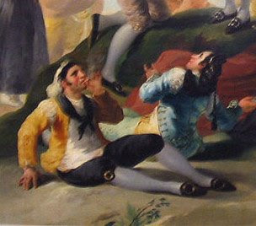
It's pretty hard to tell what color the paper is if it is indeed a cigarette. It looks like a smoker, but the details are not very clear. I tried blowing it up:
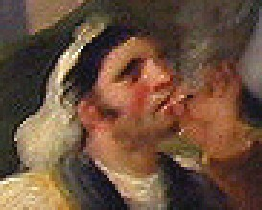
Here it looks like a light tan or possibly white coffin nail of some kind. However, it's pretty pixilated and that could just be the distorted effect of the lighting on it, too. It also appears to have smoke coming from it, which is promising. It's your best bet as far as proof from Goya suggests based on what I found with the other two paintings mentioned.
Moving on to the guy(s) in El juego de la pelota a pala, we see this (I have enlarged it a lot and lightened it a bit):
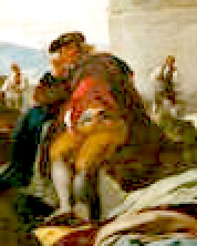
There is the man standing oddly on the rock and the guy in the background. Other than their positions, I can see but little proof that these are smokers. (There might be smoke coming from the guy in the foreground, but that might also be junk from blowing up and resizing the picture. You'd have to see the real painting to be sure.)
The last one, La Merienda en el Manzanares, is here (again, blown up dramatically):
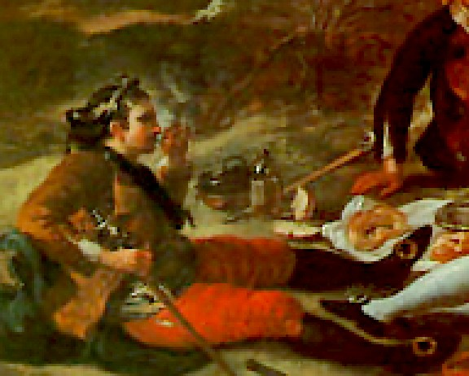
This one holds more promise as proving a cigarette in that there is a space between the guy's hand and his mouth. Blowing it way the heck up makes whatever it is look black or dark gray or dark brown. Oddly, it appears to be pointing down, which I would think would burn him based on the way he's holding his hand. But it does look like a cigar at least.
The other point of interest here is that the first painting is credited with having been done in 1777-8, the second in 1779 and the third in 1776. These are all 50+ years out of period. So I think we can safely dismiss Goya's paintings as proof that GAoP pirates might have smoked white paper-wrapped cigarettes.

Patrick Hand
- The sailor's sailor
- Moderator

- 6,100 posts
- Gender:Male
- Location:TH' Mountains of Central California
- Interests:I like wierdness... Klingon, Pyrate..... and even..... gasp.... Renn Faires...... (Baseball and tractor pulls I'd have to think about.... could be wierd or Not,,,,)
Posted July 29, 2010 · Report post
Just a fun bit to think about....
When I was going to rendezvous, I was portraying a trapper that wintered outta Taos, so cigarettes were period....(1840ish)... but back then, they were rolled in corn husk.... I've read somewhere that some of them had string to hold them together.... but most of the times you had to hold it together yourself (they weren't glued together back then...)
in the paintings, the smokers are holding their cigarettes the same way....

Brit.Privateer
- Old Twillian
- Member

- 246 posts
- Gender:Male
- Location:North Carolina
- Interests:Atlantic World Maritime History during the Colonial Era. I specialize in early provincial era (1680-1740) and do quite a bit with pirate history.
Posted July 29, 2010 · Report post
But can anyone come up with any other written proof of when the cigarette came about? Also based off those paintings, those people don't look like the lower class sort. It figures that something like cigarettes would filter down from the upper class to the lower class. I still think it's safe to say that we didn't see a lot of cigarette smoking until the 19th century.

Jackdaw
- Bilge Rat
- Member

- 10 posts
Posted July 30, 2010 · Report post
On 7/29/2010 at 5:11 PM, Brit.Privateer said:
But can anyone come up with any other written proof of when the cigarette came about? Also based off those paintings, those people don't look like the lower class sort. It figures that something like cigarettes would filter down from the upper class to the lower class. I still think it's safe to say that we didn't see a lot of cigarette smoking until the 19th century.
One of the quotes did say it was beggars who started " rolling their own ". I don't know how much tobacco was but I guess having hauled it all the way from the growing areas it was going to be a luxury item in Europe, so was probably only generally available to the wealthy. I'll see if I can come up with some primary sources.

Grymm
- First Mate
- Member

- 281 posts
- Gender:Male
- Location:Chilterns UK
- Interests:Stuff
Posted August 4, 2010 · Report post
Just to muddy the waters even more here's an article on bidis the wee Indian cigary things http://www.ias.ac.in/currsci/may252009/1335.pdf It does nowt to prove dates but means the habit could've come from India and baccy was smoked in bongs n chillums as well..........man.

Swashbuckler 1700
- Dread Pyrate
- 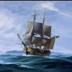
- Member

- 1,115 posts
- Gender:Male
- Location:Europe
- Interests:pyrates, pryvateers, naval military and other history, different books, good movies, music (a little bit), drawing, games,...
Posted February 5, 2014 (edited) · Report post
Just something
Originally tobacco used among natives was sometimes wrapped to something like cigars (not big news)
example: circa 1699 The Indians in their Robes in Councel, and Smoaking tobacco after their way. Illustration about a story linked to none other than Dampier and fellows.
http://jcb.lunaimaging.com/luna/servlet/detail/JCB~1~1~2297~3810003:The-Indians-in-their-Robes-in-Counc?sort=IMAGE_DATE%2Csubject_groups&qvq=q:cigar;sort:IMAGE_DATE%2Csubject_groups;lc:JCB~1~1&mi=5&trs=7
It seems that some Spaniards in Latin America used this way of smoking too
I think I have seen this here in some other thread before
Colonial Spaniard circa 1725
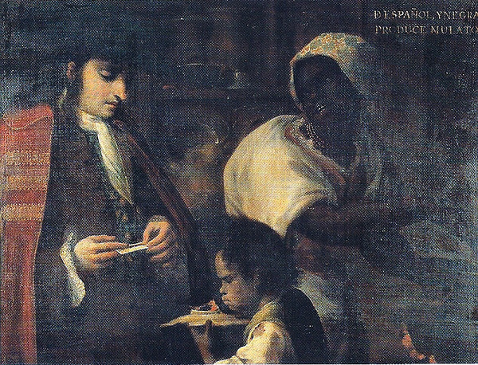
Though even while cigars (in some form) were used by Spanish colonists it doesn't mean that pirates or seafarers in general would have used the practice. Also, it seems that even Spanish colonials usually used pipes. At least they are seen much more frequently in pictures.
Edited February 5, 2014 by Swashbuckler 1700

